DXF, DWG Project

From a photo to a completed water-jet picture

DXF and DWG are two kinds of file formats that is used in many kinds of CNC-machines. We will learn more about these formats in a fun and instructively way.
In this project, we will create DXF files resembling yourself. We will delimit our picture to mostly the face and we will use a couple of programs when we create this file.
- Adobe Photoshop should be installed on your computer.
- lmg2cad is a small program for converting files, you can download a free demo of it online. Just google img2cad.
- Draftsight is a free 2D software where we handle our DXF files. You can download it.
Procedure:
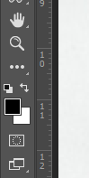
l. Take a good photograph of your face, preferably with a neutral backdrop and a light shining on your face from the side so you create some extra shadows in your face.
2. Edit the photo in Photoshop. We will later look though how to do that together.
3. Convert your Photoshoped picture to a DXF file with lmg2cad.
4. Edit the DXF file in DraftSight before we take the file to the water-jet cutter.
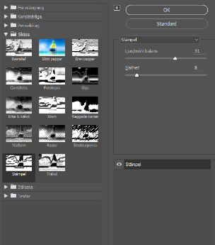
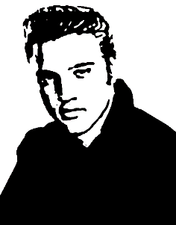
I will use a picture of Elvis Presley. It all begins with me opening my picture in Photoshop. In my case the picture I’m going to use is already black and white. But if your picture is with colour you do the same as me in the next step but be sure that your choices of colour is black and white before you do it.
You click on the tab: Filter -> Filter gallery. Then this menu will open:
Here you click on Sketch and then the tool Stamp.
Here you can adjust the parameters light/dark Balance and smoothness until you are satisfied.
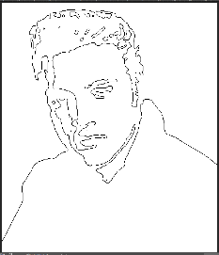
When it looks something like my picture to the right you will have a good basis.
Next step will be to click Filter -> Stylize -> Trace contour. Then all your contours will be made into lines.
Save your image as a .JPEG and then convert your file in Img2cad to a DXF.
Open your converted file in DraftSight. Highlight all lines in your image and use the tool: Explode. The Icon looks like a bomb. Now it´s time to start editing your file so that you get a working DXF file. You need to make sure that all contours are closed, that is all lines are connected to a line so you don’t have a line that ends somewhere, it all builds a circle of sorts. You also need to check that the lines doesn´t cross each other somewhere. You can´t have intersecting lines.

